ProjectDevelopment-Deliveryof

Sprint2

|  |  |
| --- | --- |
| Date | 5November2022 |
| TeamID | PNT2022TMID22515 |
| ProjectName | Project-IoTBasedSafetyGadgetfor ChildSafetyMonitoringand notification |

LOGINandNOTIFIACATIONoftheIoTdeviceinParent’sWebApplicationforgettinginformationaboutChild’sStatus.

LOGIN:-

Coding,Output,Screenshot

<!DOCTYPEhtml>

<html><head>

<metaname="viewport"content="width=device-width,initial-scale=1">

<title>LoginPage</title> <style>Body{fontfamily:Calibri,Helvetica, sansserif;background-color:#9FE2BF;

}

button{ backgroundcolor:#9FE2BF; width:100%; color:black; padding:15px; margin:10px0px; border:none; cursor:pointer;

}form{ border:

3pxsolid#f1f1f1;

}

input[type=text],input[type=password]

{ width:100%; margin:

8px0;padding:12px20px; display:inline-block; border: 2pxwhite;box-sizing:border-box;

}

button:hover

{opacity:0.7;

}

.cancelbtn{ width: auto;padding:10px 18px;margin:10px

5px;

}

.container{ padding: 25px;backgroundcolor:#CCCCFF;

}

</style></head>

<body>

<center><h1>LoginForm</h1></center>

<form>

<divclass="container">

<label>DeviceID/Number:</label>

<inputtype="password"placeholder="EnterPassword"name="password"required>

<label>E-Mail:</label>

<inputtype="text"placeholder="EnterUsername"name="username"required>

<label>Password:</label>

<inputtype="password"placeholder="EnterPassword"name="password"required>

<buttontype="submit">Login</button>

<buttonclass="loginBtnloginBtn--facebook">LoginwithFacebook.</button>

<buttonclass="loginBtnloginBtn--google">LoginwithGoogle.</button>

<inputtype="checkbox"checked="checked">Rememberme <buttontype="button"class="cancelbtn">Cancel</butt on>Forgot<ahref="#">password?</a>

</div>

</form>

</body>

</html> OUTPUT:

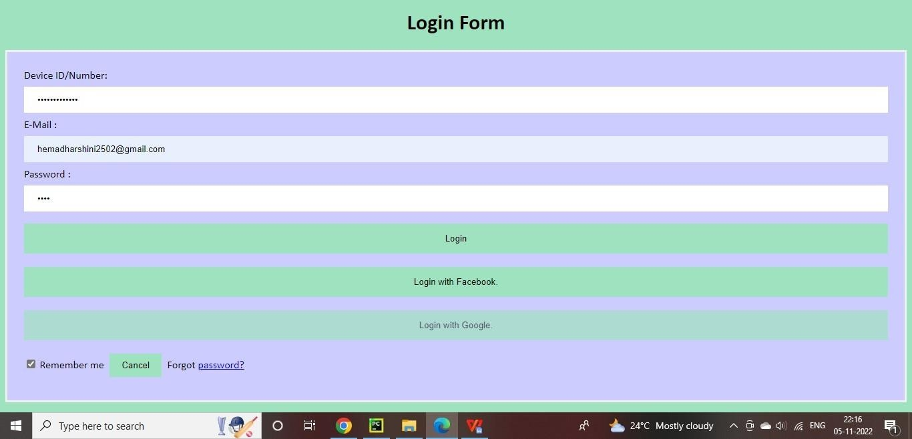

NOTIFICATION:Coding,Output-Screenshot

#include<WiFi.h>//libraryforwifi#include<PubSubClient.h>//libraryforMQTTvoidcallback(ch ar*subscribetopic,byte*payload,unsignedintpayloadlength);

//---------------credentialsofIBMAccount------

#defineORG"45z3o2"//IBMORGANIZATIONID

#defineDEVICE_TYPE"ESP32_Controller"//DEVICETYPEMENTIONEDINIOTWATSON

PLATFORM#defineDEVICE_ID"bme2"//DEVICEIDMENTIONEDINIOTWATSONPLATEFORM

#define

TOKEN"OKZ+q@JfPWDOd6wBTj"//Tok

enStringdata3;floatdist;

//------------customizetheabovevalue charserver[]=ORG

".messaging.internetofthings.ibmcloud.com";//servernamecharpublishtopic[]="ultrasonic/e vt/Data/fmt/json";/*topicnameandtypeofeventperformandformatinwhichdatatobe send*/charsubscribetopic[]="ultrasonic/cmd/test/fmt/String";/*cmd REPRESENTCommandtupeand

COMMANDISTESTOFFORMATSTRING*/ charauthMethod[]="use-token-auth";//authentication methodchartoken[]=TOKEN;char clientid[]="d:"ORG":"DEVICE_TYPE":"DEVICE_ID;//CLIENTID

//

WiFiClientwifiClient;//creatinganinstanceforwificlient

PubSubClientclient(server,1883,callback,wifiClient);/*callingthepredefinedclientidby passingparameterlikeserverid,portandwificredential*/intLED=4;inttrig=5;intecho=18;void setup(){Serial.begin(115200);pinMode(trig,OUTPUT);pinMode(echo,INPUT);pinMode(LED,OUTPUT); delay(10);Serial.println();wificonnect();mqttconnect();

}

voidloop()

{digitalWrite(trig,LOW);digital Write(trig,HIGH);delayMicrose conds(10);digitalWrite(trig,LO W);floatdur=pulseIn(echo,HIG

H);floatdist=(dur*

0.0343)/2;Serial.print("distanc

eincm");

Serial.println(dist);Publis hData(dist);delay(1000);if (!client.loop()){mqttconne ct();

}

}

/*...............................................retrivingtocloud........................................*/voidPublishData(floatdist){mqttconnect();//functi oncallforconnectingtoibm

String object;if(dis t<100)

{

digitalWrite(LED,HIGH);

Serial.println("noobjectisnear");object="Nea

r"; } else

{digitalWrite(LED,LOW);Serial.println("noobj ectfound");object="No";

}

String payload="{\"distance\":";payload +=dist;payload

+=",""\"object\":\"";payload+=object; payload+="\"}";

Serial.print("Sendingpayload:"); Serial.println(payload);

if(client.publish(publishtopic,(char*)payload.c_str())){

Serial.println("Publishok");

}else{

Serial.println("Publishfailed");

}}voidmqttconnect(){i f(!client.connected()){

Serial.print("Reconnectingclientto");

Serial.println(server);while(!!!client.connect(clientid,authMet hod,token)){Serial.print("."); delay(500);

} initManagedDevice();

Serial.println(); }}voidwificonnect()//functiondefenitionforwificonnect{

Serial.println();

Serial.print("Connectingto");

WiFi.begin("vivo1816","taetae95",6);//PASSINGTHEWIFICREDIDENTIALSTOESTABLISH

CONNECTIONwhile(WiFi.status()!=WL_CONNECTED){ delay(500);

Serial.print(".");

}

Serial.println("");Serial.println("

WiFiconnected");Serial.println(

"IP

address");Serial.println(WiFi.lo calIP()); }void

initManagedDevice(){if(client.subsc ribe(subscribetopic)){Serial.println(

(subscribetopic));

Serial.println("subscribetocmdOK");

}else{

Serial.println("subscribetocmdfailed");

}

}voidcallback(char*subscribetopic,byte*payload,unsignedintpayloadLength)

{

Serial.print("callbackinvokedfortopic:"); Serial.println(subscribetopic);for(inti=0; i<payloadLength;i++){

//Serial.print((char)payload[i]);data3+=(char)paylo ad[i];

//Serial.println(data3);

//digitalWrite(LED,LOW);//}data3="";

}

OUTPUT:

WhenchildisnotdetectedwithinthesafezonewiththehelpofIoTdevice

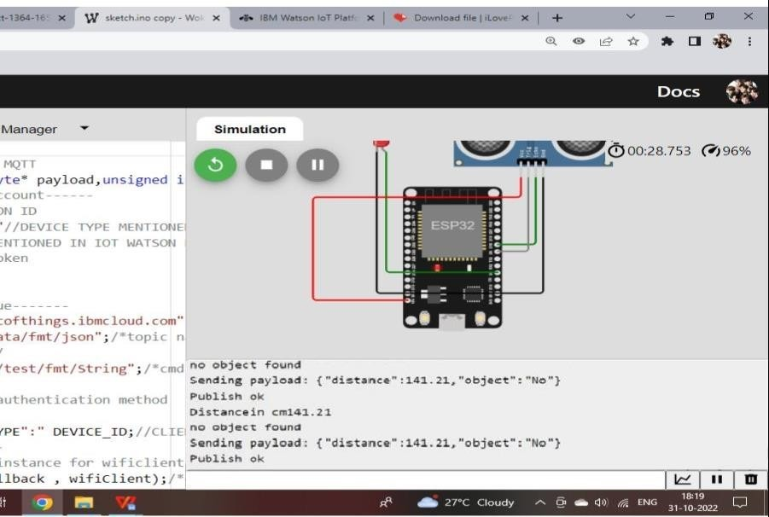

Childsstatusarenotifiedtoparentsdeviceusingcloudservice

